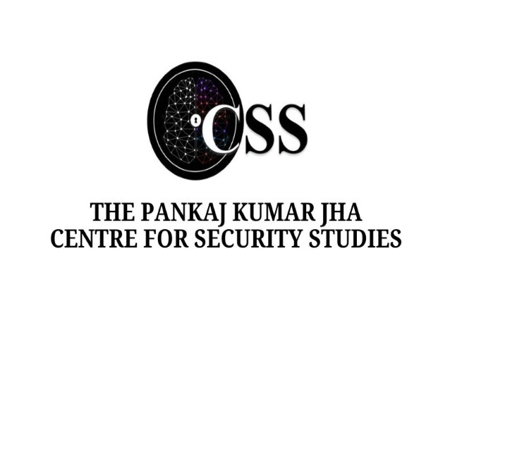

**LATE PROFESSOR (DR.) PANKAJ KUMAR JHA MEMORIAL LECTURE**

On

The Relevance of Armed Forces in the Indo-Pacific

Cooperation

Speaker: Vice Admiral Shekhar Sinha

On January 9th, 2025, the Pankaj Kumar Jha Centre for Security Studies hosted an insightful

lecture featuring Vice Admiral Shekhar Sinha, ex-Commander-in-Chief of Western Naval Command. The lecture, focusing on the Relevance of the Armed Forces in IndoPacific Cooperation, began with Harini Vallal J, the Centre Coordinator, introducing the Centre and its late founder, Prof. Pankaj Kumar Jha. It was a matter of honour and pride for the Centre to

have Mrs. Kavita Jha, wife of the late founder Prof. Pankaj Kumar Jha, attend the session. Then, the guest was introduced by Gargi Mishra, Centre Coordinator-Head of Social Media at Pankaj Kumar Jha Centre for Security Studies. It was followed by the welcome address given by Prof. Gitanjali Sinha Roy, Centre Director, PKJCSS, who offered words of remembrance in honour of the late Prof. Pankaj Kumar Jha.

At the beginning of his lecture, Vice Admiral Sinha shared his memorable experiences with the late Prof. Jha and expressed his sorrow over the loss we all felt with the passing of a mentor and great academician, Prof. Jha. Throughout the lecture, he explored the necessity of having armed forces during peacetime, not just in times of war. He highlighted the essential role the Navy plays in maintaining peace, emphasizing that the primary responsibility of the Navy in peacetime is to safeguard sea lanes, particularly for global trade, as 90% of vessels at sea are involved in commerce. He underscored that the sea is part of the global commons, and the Navy must honor the right of innocent passage for all vessels. He also noted that the Indian Navy assists ships from other nations, including Pakistan and China, that are in distress or under attack. He pointed out the Navy's vital role in preventing piracy, human trafficking, drug smuggling, terrorism, and pollution at sea. Additionally, he mentioned that the Navy is always ready to provide disaster relief and humanitarian assistance during natural or manmade crises, carrying disaster relief boxes (BRIC) on every ship. Furthermore, he stressed the Navy's global deployment, which allows it to ensure maritime security and respond to emergencies around the world.

Vice Admiral Sinha further highlighted that 80% of the world's energy is transported via the ocean, with over 60% originating from the Gulf, South America, or Africa toward the Malacca Strait. Despite the development of pipelines, especially by China, it is estimated that by 2050, 53% of China’s total oil requirements will still be fulfilled through the Indian Ocean. He emphasized that no single country's navy can guarantee the security of the entire world due to the vastness of the oceans, which cover 70% of the Earth's surface. Consequently, maritime cooperation is essential in both bilateral and multilateral relationships, as the oceans unite the world while land divides it. He noted that India prioritizes maritime cooperation agreements for this reason.

He also pointed out that during peacetime, the navy’s focus on humanitarian assistance and disaster relief (HADR) and cooperative roles, but in wartime, the armed forces must be ready for both peace and conflict scenarios. The logistics of maintaining readiness in both roles are complex since a single ship cannot carry out HADR duties while simultaneously being outfitted for combat. He stressed that navies need to be equipped for both peacetime and wartime responsibilities, often functioning in parallel. He shared that the Navy’s role in wartime mirrors peacetime, with the key difference being the use of weapons. Quoting Lenin, he rephrased his famous quote to reflect the rapid changes in geopolitics today, suggesting,

"There are decades when centuries happen."

He discussed the growing tensions around the world, from China’s actions in the Indo-Pacific to the ongoing Ukraine-Russia conflict, and China’s push for dominance in the Indian Ocean. While India’s economy is holding steady, the global supply chain has been thrown off balance, and the U.S. has seized the opportunity to weaken Russia. He also pointed out the political instability in Europe, where energy shortages and rising nationalism are making things even harder for many countries.

He pointed out that global governance models are undergoing significant shifts, particularly with President Xi Jinping’s third term. The new leadership seems to favor autocracy and stricter implementation of Marxism, though recent reports show China’s economy growing by 5% this year. He stressed that the economies of India and China, with their combined population of 2.8 billion, are crucial to the world’s economic stability. China has realized that it can’t prosper without doing business with India. He also noted that European democracies are leaning more to the right, but their economic ties with China complicate their approach.

Regarding the Indo-Pacific, he predicted China’s economic power will soon challenge the United States' position as the top global economy. Despite its economic might, China lacks many ports, which is why it has invested in ports around the world. China’s growing economic power under Xi Jinping, highlighting its shift towards autocracy and stricter Marxism was also discussed during the lecture. He emphasized that for global prosperity, China and India must cooperate, as the world economy would struggle without them. India has resisted external pressures, continuing business with Russia, and its economy is nearing $4 trillion, potentially becoming the world’s third largest.

He pointed out the emerging global bipolarity, with economic power in China and military power with the US, leading to instability. Despite China’s military growth, the US maintains a technological edge. The speaker stressed the importance of maritime trade, particularly for India, and criticized India’s low human development index and per capita income. India’s development depends on improving living standards, not just GDP. The speaker emphasized that India can't match China or the US in defense spending, urging a focus on identifying vulnerabilities and addressing them strategically. He pointed out that while India’s GDP is growing, the real impact on people’s lives needs to improve, similar to China’s progress, though it came at a cost. India’s choice of democracy contrasts with China’s model, and despite global peace hopes after the Soviet Union’s collapse, the world became more turbulent.

Geographically, the Indo-Pacific is shaped by four major powers— Russia, China, the US, and India. The speaker sees the world heading toward multipolarity, with Africa and South America emerging as centers of power alongside the established powers. Vice Admiral Sinha also emphasized the growing importance of maritime power in global geopolitics. Drawing on history, he highlighted how Britain's naval dominance shaped its influence, contrasting with India's historical land-centric focus, which is now shifting under PM Modi's leadership. He noted China's expanding global ambitions, especially in the Indo-Pacific, and the region's reliance on democratic powers like the US and India for security, despite economic ties with China. India’s naval build-up, while strategic, raises concerns among neighbors like Bangladesh and Pakistan.

On Trump’s potential policies, Vice Admiral Sinha expressed skepticism, noting his unpredictability could lead to a power vacuum, enabling China's rise. He stressed the role of navies in ensuring security, cooperation, and economic stability in a maritime-centric world. Vice Admiral Sinha anticipated turbulent times under Trump’s unpredictable leadership, emphasizing the role of his China-hawk advisors, like Rubio, in shaping US policies. He cautioned about potential instability if American forces withdraw, empowering local power players.

On India’s challenges, he highlighted diplomatic struggles and military preparedness, especially concerning Bangladesh and its ties to the Arakan Army near the Chittagong Hill Tracts. Referring to Sri Lanka and Maldives, Sinha stressed India's consistent "neighborhood first" policy, prioritizing aid and relations with people over governments. He concluded with optimism, citing India's efforts to maintain regional stability under the vision of Vasudhaiva Kutumbakam.

In an engaging question-answer round, when asked about the Indian

Navy's challenges and focus on the southern front, Vice Admiral Sinha highlighted the Navy's readiness to handle threats, reduce Army pressure, and monitor Indian Ocean choke points. He stressed advancements in maritime awareness through private sector contributions and criticized PSU inefficiencies, advocating privatization. He also warned of China's naval and space advancements, urging strategic countermeasures while balancing India's economic priorities.

The Vice Admiral addressed the shift from sea denial to sea control strategy, highlighting India's partnerships like QUAD and Malabar for regional stability and readiness in the Indo-Pacific. He noted the need for more assets, including amphibious ships, aircraft carriers, and P-8I aircraft for surveillance. On readiness for a Parakram-like situation against China, he emphasized improvements in naval capabilities, including submarines for offensive roles and advanced tracking systems, and stressed robust maritime domain awareness and collaboration with allied nations. Following the Q and A session, Kavita Ma’am expressed her heartfelt appreciation, stating that it was wonderful to see Professor Jha’s legacy being carried forward through such meaningful discussions and initiatives.

As Professor Pooja Bhatt concluded the event, she extended her heartfelt gratitude to Admiral Sinha for sharing his invaluable insights, emphasizing the importance of combining theoretical and practical perspectives for the students. She also expressed appreciation for the presence and heartfelt words of Kavita Ma’am, assuring that Professor Jha’s vision would continue to guide their efforts in shaping the next generation of leaders. In her closing remarks, she emphasized the centre's commitment to continuing the tradition of such impactful lectures and expressed hope that everyone present would continue to support and contribute to the centre's mission.