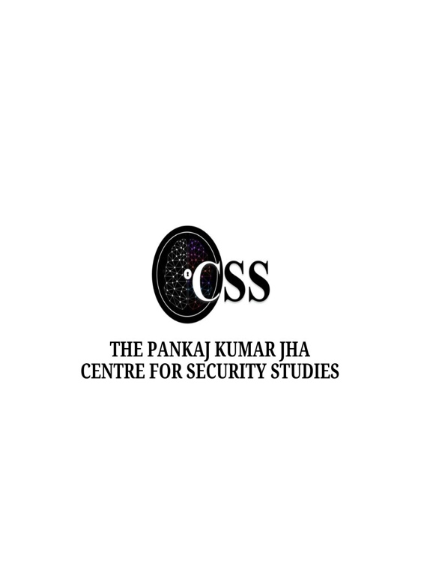
PKJCSS EVENT REPORT

“TERROR FINANCE – PAST AND CURRENT TRENDS”

Led by: Colonel Vivek Chadha, with coordination from Prof. (Col) Shashank Ranjan and Prof. Pooja Bhatt.

Colonel Chadha’s presentation aimed to provide insights into the methods and motivations behind terrorism financing and highlighted the challenges in addressing this evolving threat. By structuring the presentation around three core areas—characteristics of terrorism finance, evolving trends, and future prospects—he sought to outline the complexity of terror financing operations, especially those rooted in traditional financial systems and rapidly advancing digital technologies. His focus on Asia and India emphasized region-specific risks and patterns in terrorism financing. The session opened with a powerful quote from Prime Minister Modi in 2022: “No money will be given to terror.” This statement set the tone for a comprehensive discussion on the mechanisms, trends, and challenges associated with terrorism financing in today’s geopolitical climate, especially within Asia and India.
One of the foundational aspects of Chadha’s talk was the “Trinity of Terrorism”, which he identified as essential for understanding the endurance of terrorist organizations. He defined this trinity as follows: “Motivation”, where ideology drives individuals towards terrorism; “Control”, achieved by establishing influence over people who share the same ideology; and “Lifeblood (Funding)”, which he described as the financial backbone that sustains terrorist activities, much like blood sustains the human body. This trinity highlighted the multifaceted approach terrorist organizations use to maintain influence, attract supporters, and finance operations. Col. Chadha described various characteristics of terror financing, noting how it often exploits both legal and illegal channels. Legal structures, such as money laundering, provide a front for terrorist funds to flow through formal financial systems without suspicion. He also discussed how religious narratives are often leveraged to justify and encourage fundraising activities, thus securing ideological and financial support. The speaker emphasized the speed at which terrorism financing tactics evolve, noting that these changes often outpace regulatory measures and demand constant adaptation. Terrorist financing is thus marked by its flexibility, adaptability, and strategic focus on ensuring the longevity and growth of the organizations it supports.
Colonel Chadha illustrated the diverse approaches to terrorism financing across Asia through specific case studies. In “Singapore” (2022), a self-radicalized individual aligned with the Islamic State of Iraq and Syria transferred SGD 891 through online platforms to entities linked with terrorist activities in Syria. The “Philippines” case involved a project director of a non-profit organization who accumulated over USD 15,309 in cryptocurrency, transferring funds to various accounts suspected of supporting terror-linked groups. In “Indonesia”, a foundation associated with terrorism raised approximately USD 17,000 through donation boxes, charity events, and partnerships with local organizations, funneling funds to potentially extremist entities. These cases highlighted the growing role of digital platforms and non-traditional currencies in facilitating terror financing across borders. Based on the 2023 Asia Pacific Group Regional Report, Chadha shared trends specific to terrorism financing in Asia, where online fundraising is on the rise, and terrorists increasingly rely on internet platforms for global outreach. Additionally, family-based fundraising and non-banking money transfer systems are common methods. Funds are also moved through traditional bank accounts, cash, and, notably, non-bank money transfer systems that don’t require formal accounts. Such trends reflect how terrorists utilize both old and new financial systems, complicating efforts to trace and intercept funding.
Colonel Chadha discussed how terror financing methods blend traditional and emerging technologies, creating a dual-track approach. While traditional methods like “Hawala” are still prevalent, cryptocurrency represents an emerging frontier, offering terrorists decentralized and often anonymous means of transferring funds across borders. This combination of physical carriage and autonomous transfer methods poses significant regulatory challenges, as both traditional and digital channels have proven effective for terrorism financing.
India faces unique challenges due to a hybrid financing model that combines both external and internal funding sources. External sources include state sponsorship, NGOs, donations, counterfeit currency, and drug trafficking, while internal sources encompass extortion, crime-related profits, business earnings, and local drug sales. Methods for transferring funds include banking channels, cash, trade routes, Hawala, and even couriers. Colonel Chadha identified the “Malda hub” as a critical point in the distribution of counterfeit currency in denominations of INR 2000 and INR 500. This complex network of funding sources and transfer methods underscores the difficulty India faces in curbing terrorism financing within its borders.
In his analysis, Col. Chadha provided a forward-looking perspective on terrorism financing, highlighting virtual currency’s growing role in terror funding. He underscored how money laundering, criminal activity, and terrorism financing are increasingly interconnected, further complicating efforts to combat them. India’s proximity to Pakistan, a primary source of terror financing, remains a challenge, especially with the rise of autonomous couriers and carriers who evade standard regulatory measures. Furthermore, terrorists exploit under-governed regions, complicating efforts to track and control funding. These challenges call for innovative countermeasures and strong international collaboration. The session ended with a interactive Q and A session where students raised insightful questions about the complexities of countering terror financing. In conclusion, Colonel Chadha’s presentation on the past and current trends in terrorism financing emphasized the complexity and adaptability of financing methods. His insights underscore the necessity for evolving counter-terrorism measures, especially as technology advances and financial channels diversify. Addressing terrorism financing effectively will require not only strategic adaptation but also a robust, collaborative international approach to secure a sustainable, terror-free future.

